**Roll No.**

**Batch No.**

**Name:**

**Experiment No. 10**

**Title: Analysis of IR spectrum**

Aim: To analyze the IR spectrum.

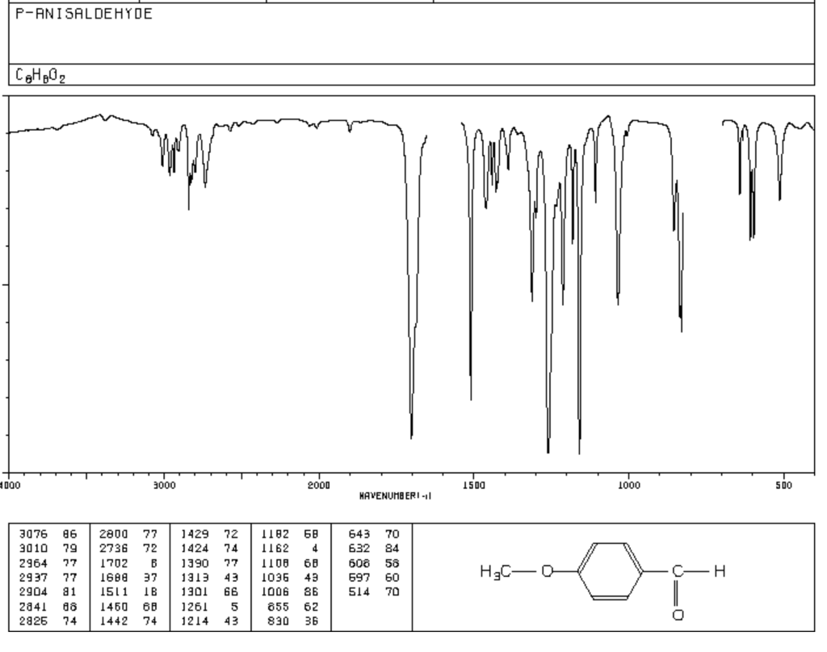

**Result:** Important IR frequencies of above compound are

|  |  |  |  |
| --- | --- | --- | --- |
| **IR frequency**  **(cm-1)** | **Functional Group** | **IR frequency**  **(cm-1)** | **Functional Group** |
| 3076-3010 | Aromatic C-H | 1511, 1600 | Aromatic C=C |
| 2937-2904 | Alkyl C-H | 1108, 1036 | Ether C-O |
| 2841, 2736 | Aldehyde C-H | 1460, 1390 | Alkane C-H (bending) |
| 1688 | Aldehyde C=O |  |  |

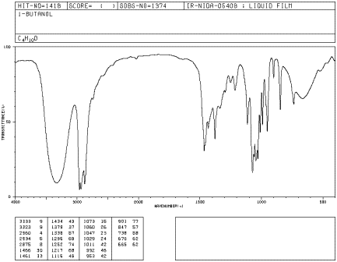

**Result:** Important IR frequencies of above compound are

|  |  |  |  |
| --- | --- | --- | --- |
| IR frequency | Functional Group | IR frequency | Functional Group |
|  |  |  |  |
|  |  |  |  |
|  |  |  |  |
|  |  |  |  |

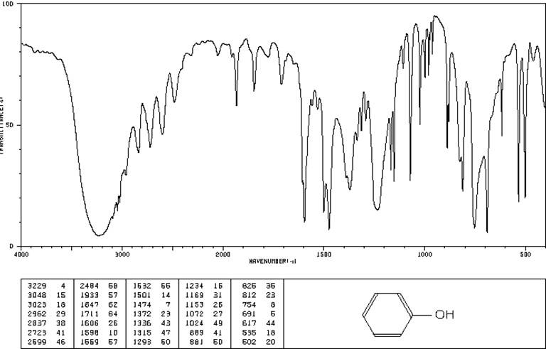

**Result:** Important IR frequencies of above compound are

|  |  |  |  |
| --- | --- | --- | --- |
| IR frequency | Functional Group | IR frequency | Functional Group |
|  |  |  |  |
|  |  |  |  |
|  |  |  |  |
|  |  |  |  |

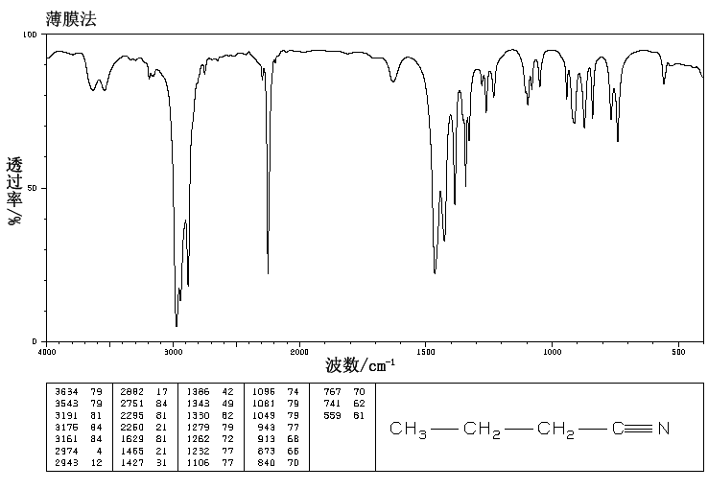

**Result:** Important IR frequencies of above compound are

|  |  |  |  |
| --- | --- | --- | --- |
| IR frequency | Functional Group | IR frequency | Functional Group |
|  |  |  |  |
|  |  |  |  |
|  |  |  |  |
|  |  |  |  |